Minor project Report

on

**GENERATION OF AM USING**

**SQUARE LAW MODULATOR**

Submitted by

**M. Sai Kishore (171FA05305)**

**R.V.L. Karthik (171FA05329)**

**S. Tushar (171FA05362)**

**In**

**Electronics and Communication Engineering**

*Under the Esteemed Guidance of*

**Mr. P. Joshua Reginald**



**DEPARTMENT OF**

**ELECTRONICS & COMMUNICATION ENGINEERING**

**VFSTR, VADLAMUDI**

**GUNTUR-522213, ANDHRA PRADESH, INDIA**

**April 2019**

**CERTIFICATE**

This is to certify that the minor project report entitled **Generation of AM using Square Law Modulator** that is being submitted by **M. Sai Kishore, R.V.L. Karthik, S. Tushar** bearing **Regd. No. 171fa05305, 171fa050329, 171fa05362** in partial fulfilment for the award of II year II semester B.Tech degree in Electronics and Communication Engineering to Vignan’s Foundation for Science Technology and Research , is a record of work carried out under the guidance of **Mr. P. Joshua Reginald** of ECE Department.

Signature of the faculty guide Signature of Head of the Department

Mr. P. Joshua Reginald Dr. T. Pitchaiah, Professor

|  |  |  |
| --- | --- | --- |
| s.no | Contents | Page no. |
| 1 | Abstract | 4 |
| 2 | Introduction | 5 - 7 |
| 3 | Block diagram | 8 |
| 4 | Matlab code | 9 |
| 5 | Simulink block diagram | 10 |
| 6 | Output waveforms | 11 |
| 7 | Advantages and disadvantages | 12 |
| 8 | Applications | 12 |
| 9 | Result | 12 |
| 10 | References | 13 |

Table of contents

Abstract:

**The main objective of this project is to design a square law modulator by using MATLAB software. And we give a message signal as input to square law Modulator in that carrier signal propagates according to message signal. Hence, we get an amplitude modulated signal that is shown in output graph.**

**Introduction:**

In communication it is important to transmit signals through a long distance, for this we are doing modulation of signal. Modulation is the process of varying one or more properties of a periodic [waveform](https://en.wikipedia.org/wiki/Waveform), called the [carrier signal](https://en.wikipedia.org/wiki/Carrier_signal), with a modulating signal that typically contains information to be transmitted.  Most radio systems in the 20th century used [frequency modulation](https://en.wikipedia.org/wiki/Frequency_modulation) (FM) or [amplitude modulation](https://en.wikipedia.org/wiki/Amplitude_modulation) (AM) for  [radio broadcast](https://en.wikipedia.org/wiki/Radio_broadcast). A modulator is a device that performs modulation. A demodulator (sometimes detector ) is a device that performs [demodulation](https://en.wikipedia.org/wiki/Demodulation), the inverse of modulation. Modulation transmits the signal through a large distance with out any distortion and attenuation. By doing modulation we can also reduce the height of the antenna.

In analogue communications modulation is divided into the following types:

[**Amplitude modulation**](https://en.wikipedia.org/wiki/Amplitude_modulation)**(AM)**: Here the amplitude of the carrier signal is varied in accordance with the instantaneous amplitude of the modulating signal.

[**Frequency modulation**](https://en.wikipedia.org/wiki/Frequency_modulation)**(FM):** Here the frequency of the carrier signal is varied in accordance with the instantaneous amplitude of the modulating signal.

[**Phase modulation**](https://en.wikipedia.org/wiki/Phase_modulation)**(PM)**: Here the phase shift of the carrier signal is varied in accordance with the instantaneous amplitude of the modulating signal.

In this project we are dealing with amplitude modulation so let us take a brief understanding about AM.

**AMPLITUDE MODULATION:**

AM was the earliest modulation method used to transmit voice by radio. It was developed during the first quarter of the 20th century beginning with [Landell de Moura](https://en.wikipedia.org/wiki/Landell_de_Moura) and [Reginald Fessenden](https://en.wikipedia.org/wiki/Reginald_Fessenden)'s [radiotelephone](https://en.wikipedia.org/wiki/Radiotelephone) experiments in 1900. It remains in use today in many forms of communication; for example it is used in portable [two-way radios](https://en.wikipedia.org/wiki/Two-way_radio), [VHF aircraft radio](https://en.wikipedia.org/wiki/Airband), [citizens band radio](https://en.wikipedia.org/wiki/Citizens_band_radio), and in computer [modems](https://en.wikipedia.org/wiki/Modem) in the form of [QAM](https://en.wikipedia.org/wiki/QAM). AM is often used to refer to [mediumwave](https://en.wikipedia.org/wiki/Mediumwave) [AM radio broadcasting](https://en.wikipedia.org/wiki/AM_broadcasting).

One disadvantage of all amplitude modulation techniques (not only standard AM) is that the receiver amplifies and detects [noise](https://en.wikipedia.org/wiki/Noise_(radio)) and [electromagnetic interference](https://en.wikipedia.org/wiki/Electromagnetic_interference) in equal proportion to the signal. Increasing the received [signal-to-noise ratio](https://en.wikipedia.org/wiki/Signal-to-noise_ratio), say, by a factor of 10 (a 10 [decibel](https://en.wikipedia.org/wiki/Decibel) improvement), thus would require increasing the transmitter power by a factor of 10. For this reason AM broadcast is not favored for music and [high fidelity](https://en.wikipedia.org/wiki/High_fidelity) broadcasting, but rather for voice communications and broadcasts (sports, news, [talk radio](https://en.wikipedia.org/wiki/Talk_radio) etc.). Another disadvantage of AM is that it is inefficient in power usage; at least two-thirds of the power is concentrated in the carrier signal.

Amplitude of the carrier signal is varied in accordance with the instantaneous value of the message signal is known as amplitude modulation.

s(t)=Ac*[1+Kₐm(t)] *cos(2πfᴄt)

Where,

s(t) = Modulated Signal

m(t) = Message Signal

Ac = Amplitude of Carrier Signal

Ka = Sensitivity of Modulation

fc = Frequency of Carrier Signal

Methods to generate AM signal:

There are two methods used for AM Modulation.

* 1. Square law Modulator
  2. Switching Modulator

SQUARE LAW MODULATOR:

Here we are doing amplitude modulation using square law modulator.

Square law modulator, is one of the methods to generate AM (Amplitude Modulated) signals. In amplitude modulation the amplitude of the carrier wave is varied in proportion to that of message signal.

Square law modulator consists of:

*A Non-Linear Source

*A band pass filter

*A carrier signal source

*A message signal source

The carrier and message signal are connected in series with each other.

They are connected in series such that their sum is given as input to non-linear device.

v1(t)=m(t)+Ac*cos(2*pi*fc*t)

The non-linear device used here, can be a diode.

The input output relation of Non-linear device is

v2(t)=a*v1(t)+b*v^2(t)

Here, a and b are constants.

When, the output of Non-linear device is passed through the bandpass filter, we get our desired output, i.e., Amplitude Modulated signal.

S(t)=Ac[1+ka*m(t)]cos(2*pi*fc*t)

Here ka is amplitude sensitivity.

**BLOCK DIAGRAM OF SQUARE LAW MODULATOR:**

V^2(t)

V1(t)

sum

m(t) +

Band pass filter

Non linear device

S(t)

+

Ac*cos(2*pi*fc*t)

**Program:**

clc;

clear all;

close all;

t = 0:0.0001:2;

fs = 10000;

Am = 0.25;

fm = 10;

Ac = 1;

fc = 100;

mt = Am.*cos(2*pi*fm*t);

ct = Ac.*sin(2*pi*fc*t);

v1t = mt + ct;

v2t = v1t + v1t.*v1t;

order = 3;

fcutlow = fc-fm;

fcuthigh = fc+fm;

[b,a] = butter(order,[fcutlow,fcuthigh]/(fs/2), 'bandpass');

st = filter(b,a,v2t);

figure;

subplot(3,1,1);

plot(t,mt);

title('Message Signal');

xlabel('Time');

ylabel('Amplitude');

subplot(3,1,2);

plot(t,ct);

title('Carrier Signal');

xlabel('Time');

ylabel('Amplitude');

subplot(3,1,3);

plot(t,st);

title('Modulated Signal');

xlabel('Time');

ylabel('Amplitude');

**Simulink Block Diagram:**

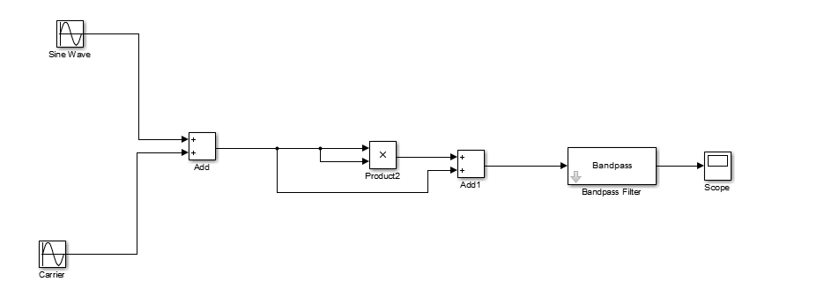

1. **Initializations:**

**m(t):**

Amplitude= 1

Frequency=10Hz

Sample time=0.0001

**c(t):**

Amplitude=-1

Frequency=100Hz

Sample time=0.0001

**Bandpass Filter:**

Band Reject Frequency : 89Hz

Band pass Frequency : 90Hz

Band pass Frequency : 110Hz

Band Reject Frequency : 111Hz

Order : 3

Type : Butterworth

**Output Waveforms:**

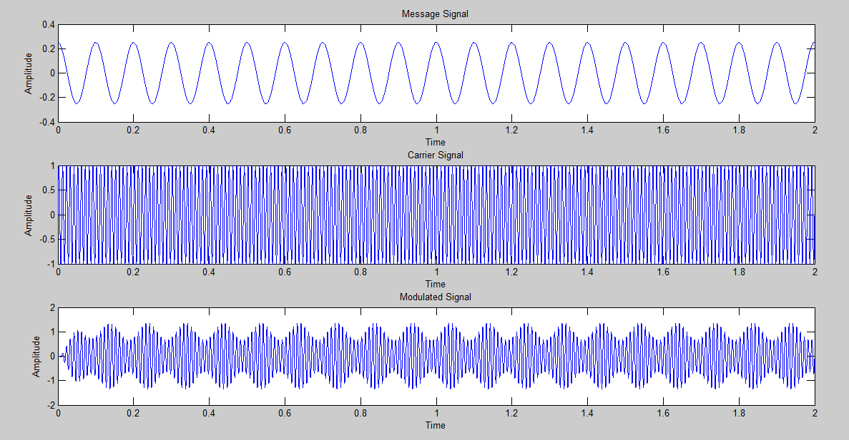 **MATLAB Output**

**7.2 Simulink Output:**

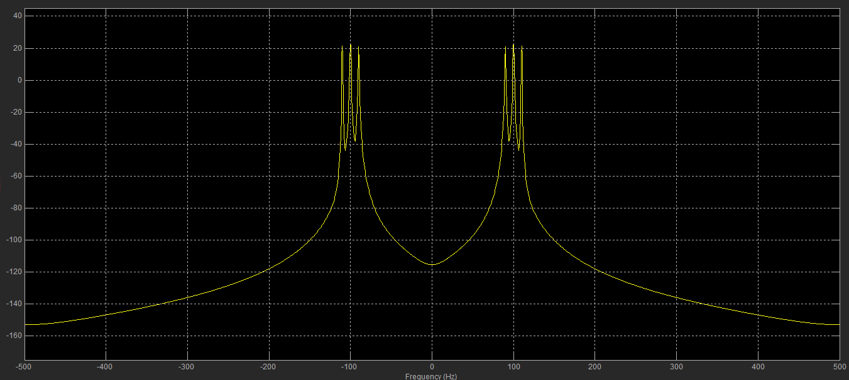

**Advantages:**

* A large number of signals can be transmitted simultaneously.
* It does not need synchronization between transmitter and receiver for proper operation.
* Demodulation is easy.

**Disadvantages:**

* The communication channel must have a large band width.
* Large number of modulators and filters are required.
* Suffers from problem of cross talk.
* Channel gets affected due to wide band fading.

**Applications:**

* + TV broadcasting.
  + Air traffic control radios.
  + Transmission of color information in TV signals.

1. **Result:** Hence, DSB-SC signal is generated using balanced modulator by using MAT LAB.

**REFERENCES**

[1] “Analog Communication” by Sanjay Sharma.

[2] MathWorks.